A Project Report On

**YOUTUBE TRENDING VIDEOS**

Submitted in partial fulfillment of the requirement for the award of the degree

MASTER OF COMPUTER APPLICATIONS

(INTEGRATED)

from

Gujarat Technological University



Academic Year 2019 – 20

**Krunal Bhanderi(165220686004)**

**Yash Dhameliya (165220686009)**

|  |
| --- |
| Internal Guide |
|  |

**Pro. Sunil Bajeja**



Marwadi Education Foundation’s Group of Institutions

(MEFGI)

Rajkot-Morbi Road, At &PO :Gauridad, Rajkot 360 003. Gujarat. India.



**Faculty of Computer Applications (FCA)**



**This is to certify that the project work entitled**

**YouTube Trending Videos**

**submitted in partial fulfillment of the requirement for**

**the award of the degree of**

**Master of Computer Applications**

**(Integrated)**

**of the**

**Gujarat Technological University**

**is a result of the Bonafede work carried out by**

**Krunal Bhanderi(165220686004)**

**Yash Dhameliya (165220686009)**

**during the academic year 2019 – 2020**

|  |  |  |  |  |
| --- | --- | --- | --- | --- |
| **Faculty Guide** |  |  |  | **HOD** |

**External Viva**

|  |  |  |
| --- | --- | --- |
| **Name of the Examiners** |  | **Signature with Date** |

**CERTIFICATE**

**DECLARATION**

We hereby declare that this project work entitled **YouTube Trending Videos** is a record done by us.

We also declare that the matter embodied in this project is genuine work done by me and has not been submitted whether to this University or to any other University / Institute for the fulfillment of the requirement of any course of study.

Place: **_____________________**

Date: **_____________________**

**Krunal Bhanderi (165220686004) Signature: _________**

**Yash Dhameliya (165220686009) Signature: _________**

**ACKNOWLEDGEMENT**

It is indeed a great pleasure to express our thanks and gratitude to all those who helped us. No serious and lasting achievement or success one can ever achieve without the help of friendly guidance and co-operation of so many people involved in the work.

We are very thankful to our guide **Dr. Sunil Bajeja,** the person who makes us to follow the right steps during a project work. We express our deep sense of gratitude to for her guidance, suggestions and expertise at every stage. A part from that her valuable and expertise suggestion during documentation of our report indeed help us a lot.

Thanks to our friend and colleague who have been a source of inspiration and motivation that helped to us during our project work.

We would heartily thankful to Head and Dean of our department **Dr. Sunil Bajeja and Dr. R. Sridaran** to give us an opportunity to work over this report and for their end-less and great support. And to all other people who directly or indirectly supported and help us to fulfil our task.

**Krunal Bhanderi (165220686004) Signature: _________**

**Yash Dhameliya(165220686009) Signature: _________**

**CONTENTS**

|  |  |  |
| --- | --- | --- |
| **Chapters** | **Particulars** | **Page No.** |
| **1** | **INTRODUCTION** | 1 |
| **2** | **PROBLEM STATEMENT** | 2 |
| **3** | **ORGANIZATION OF DATA** | 3 |
| **4** | **DATA VISULIZATION THROUGH SUMMARY** | 4 |
| **5**  5.1  5.2  5.3  5.4 | **METHOD/TECHNIQUES**  Identification of technique and tool used  Application of techniques and tools used  Discuss the assumptions that inference procedure has  Discuss how you will check those assumptions | 5  6  6  6 |
| **6** | **PRILIMINARY ANALYSIS** | 7-11 |
| **7** | **GRAPHICAL DESCRIPTION OF DATA** | 12-49 |
| **8** | **CONCLUSION** | 50 |
| **9** | **BIBLIOGRAPHY** | 51 |

1. **INTRODUCTION**

YouTube (the world-famous video sharing website) maintains a list of the top trending video on the platform. [According to Variety magazine](http://variety.com/2017/digital/news/youtube-2017-top-trending-videos-music-videos-1202631416/), “To determine the year’s top-trending videos, YouTube uses a combination of factors including measuring users’ interactions (number of views, comments and likes). Note that they’re not the most-viewed videos overall for the calendar year”.

This dataset is a daily record of the top trending YouTube videos.

Data includes the video id, video title, channel title, publish time, tags, views, likes and dislikes, thumbnail, comment disable, rating disable, video error or removed, description, and comment count.

1. **PROBLEM STATEMENT**
2. What is relation between video likes, dislike and ranking?
3. What is relation between comment count and ranking?
4. What is relation between video view and ranking?
5. Do tags of video affect the video ranking?
6. Effects of video publish time on video ranking.
7. Percentage of videos that being deleted or face some error.
8. Percentage of videos that comment and ratings were disable.
9. **ORGANIZATION OF DATA**

This dataset contains information of athlete events from 1998 to 2016, Which amounts to 12826 athlete events total. It contains 12826 observation of 14 variables, which

This database contain information of trending videos on YouTube. It contain 40,000 observation on 15 different values which include the video id, video title, channel title, publish time, tags, views, likes and dislikes, thumbnail, comment disable, rating disable, video error or removed, description, and comment count.

1. video_id:

This field contains unique video id.

1. trending_date:

This field contains the date on which date specific video was in trending.

1. Title:

This field contains the video title.

1. channel_title:

This field contains the channel name related to video.

1. publish_time:

This field contains the date of publish including time.

1. Tags:

This field contains the video tags that helps to search related videos.

1. Views:

This field contains total number of views of videos.

1. Likes:

This field contains total number of likes given to video.

1. Dislikes:

This field contains total number of dislikes given to video.

1. comment_count:

This field contains total count of comments given to the video.

1. thumbnail_link:

This field contains the link of cover image of video uploaded on YouTube.

1. comments_disabled:

It shows the comment section is enabled or disabled.

1. ratings_disabled:

It shows the ratings are enabled or disabled for paid content.

1. video_error_or_removed:

It shows the video status for check the video exists or not and also check whether the video has some errors or not.

1. Description:

This field shows the description of video.

1. Category_id:

Specify the category of video like Music, Movies, Sports etc.

1. **DATA VISUALISATION THROUGH SUMMARY**

1. How did I obtain the data set?

* I got the dataset from kaggle website. It contain information about trending videos on YouTube.

2. How the data originally collected?

* Data is collected from YouTube website that maintains the record of all trending videos on YouTube.

3. How many rows and columns are in the dataset?

* There are 40882 rows and 15 columns.

4. What are the columns in dataset?

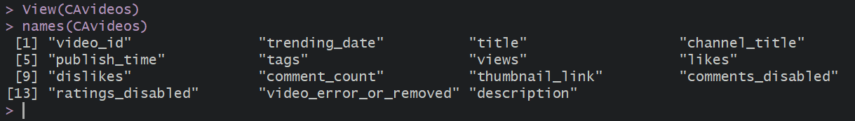

1. **METHODS / TECHNIQUES**
2. **Identification of techniques and tool used**

R is a programming language and software environment for statistical analysis, graphics representation and reporting R was created by Ross Ihaka and Robert Gentleman at the University of Auckland, and is currently development by the R Development Core Team. R is freely available under the GNU General Public License, and per-compiled binary version are provided for various operating systems like Linux, Windows and Mac. This programming language was named R, based on the first letter of first name of the two R authors (Robert Gentleman and Ross Ihaka), and partly a play on the name of the Bell Labs Language S.

As stated earlier, R is a programming language and software environment for statistical analysis, graphics representation and reporting. The following are the important features of R -

* R is a well-developed, simple and effective programming language which includes condition, loops, user defined recursive functions and input and output facilities.
* R has an effective data handling and storage facility.
* R provides a suite of operators for calculations on array,lists,vectors and matrices.
* R provides a large, coherent and integrated collection of tools for data analysis.
* R provides graphical facilities for data analysis and display either directly at the computer or printing at the papers.

As a conclusion, R is world’s most widely used statistics programming language. It’s the #1 choice of data scientists and supported by a vibrant and talented community of contributors. R is taught in universities and deployed in mission critical business applications. This tutorial will teach you R programming along with suitable examples in simple and easy steps.

1. **Application of techniques and tools used**

* R will provide numerical or graphical summaries of data
* R has extensive graphical abilities
* R will handle a variety of specific analyses : Correlation, Straight Line Regression

1. **Assumption**

According to the Research and Innovative Technology Administration Bureau of Sports Statistics, this athlete dataset includes information about every games that departed form New York City in 2016. Therefore, due to the size and amount of data collected here, we can make the assumption that this dataset exhibits randomization without any bias.

**Randomize : What is the Randomization Scheme?**

While our original assumption claimed that the entire sports dataset exhibits randomization, our analysis needed to ensure that we developed a completely randomization design. In meeting this objective, a new dataset is created(“athlete”) that randomly selects 12826 observations from “data_raw”. In creating this new dataset, we’re ensuring that our analysis considers a large sample of an even larger population and randomizes the order that the runs of the data are placed in the dataset (since they were originally listed chronologically by departure date.) After creating this new dataset, we can now assume that our randomization scheme represents a completely randomized design.

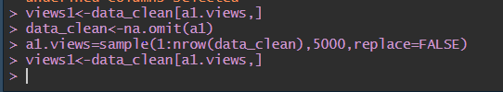

1. **PRELIMINARY ANALYSIS**

* The number of rows and number of columns in the dataset:

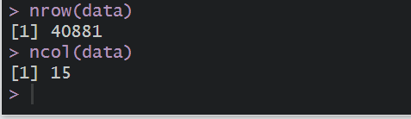

* The first six value in dataset

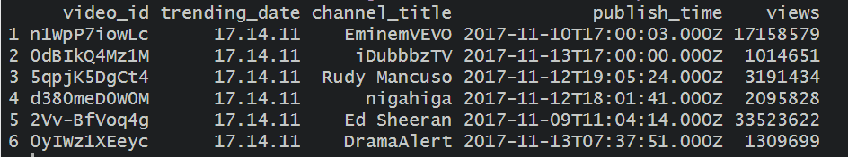

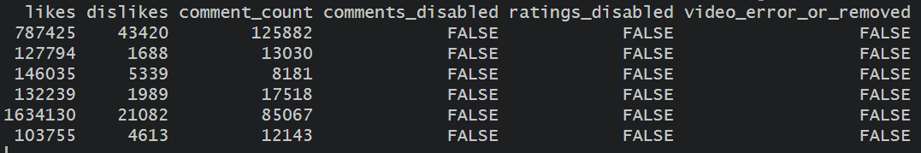

* The last six values in dataset

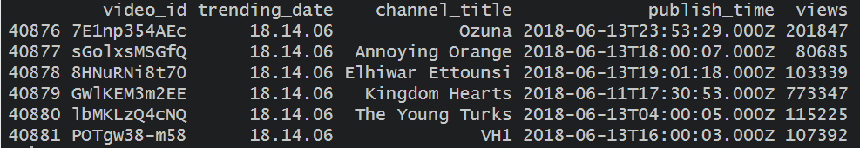

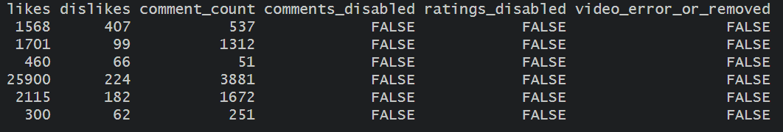

* Names of variables:

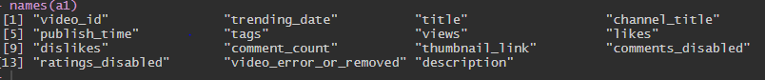

* Factors and levels of variable “comment_disabled”:



* Factors and levels of variable “trending_date”:

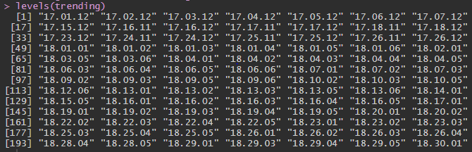

* Structure of dataset

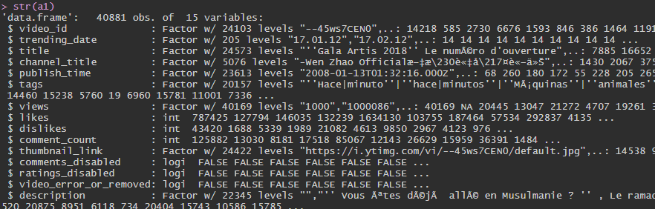

* Data Cleansing : omit NA cases using the na.omit function and recode the “views” column using indexing and reassignment



* What was the mean, median and standard deviation of views?

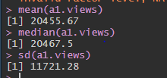

**The mean views is 20455.67 views with a standard deviation of 11721.28 views. The median is at 20467.5 views.**

1. **GRAPHICAL DESCRIPTION OF DATA**

* **Reading CSV**

a1=read.csv(file = "c:/krunal/CAvideos.csv")

* **Bar graph of video uploads on each day of week**

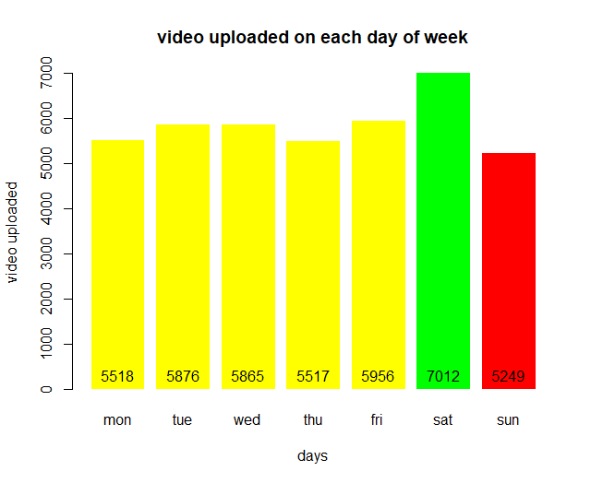

install.packages("lubridate")

sun=0

mon=0

tue=0

wed=0

thu=0

fri=0

sat=0

library(lubridate)

for (i in a1["publish_time"])

{

for (b in i)

{

c=strsplit(b,"T")[[1]]

date=ymd(c[1])

a=wday(date)

# switch(a,mon=mon+1,tue=tue+1,wed=wed+1,thu=thu+1,fri=fri+1,sat=sat+1,sun=sun+1)

if(a==1)

{

mon=mon+1

print(mon)

}else if(a==2){

tue=tue+1

}else if(a==3){

wed=wed+1

}else if(a==4){

thu=thu+1

}else if(a==5){

fri=fri+1

}else if(a==6){

sat=sat+1

}else if(a==7){

sun=sun+1

}

print(count)

count=count+1

}

}

install.packages("lubridate")

date<-ymd("2019-01-12")

print(wday(date))

da=c(mon,tue,wed,thu,fri,sat,sun)

da1=c("mon","tue","wed","thu","fri","sat","sun")

f<-barplot(da,main="video uploaded on each day of week",xlab = "days",ylab = "video uploaded",args.legend=list(bty="n",horiz=TRUE) , border="white",names.arg = da1,col="yellow")

f

* **Area graph of video count based on description length**

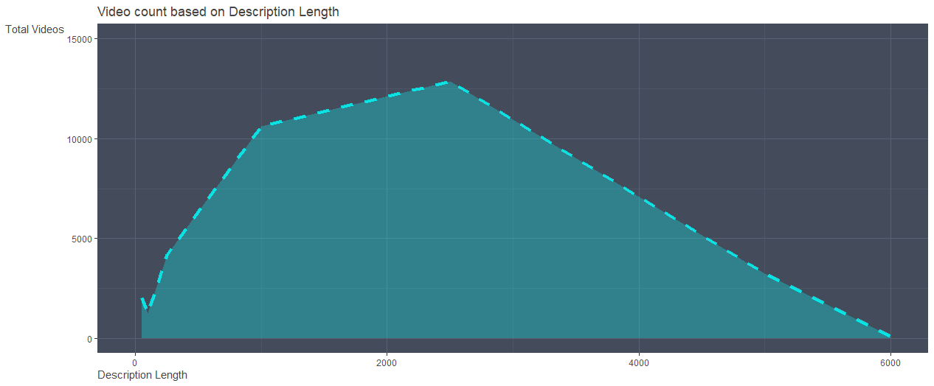

install.packages("gganimate")

install.packages("babynames")

install.packages("grbrthemes")

library(ggplot2)

library(gganimate)

library(babynames)

library(hrbrthemes)

count=l10=l20=l30=l40=l50=l60=l70=l80=l90=l100=0

for (i in a1$description)

{

for (c in i)

{

b=nchar(c)

print(b)

if(b<50)

{

l10=l10+1

}else if(50<b & b<100){

l20=l20+1

}else if(100<b & b<250){

l30=l30+1

}else if(250<b & b<500){

l40=l40+1

}else if(500<b & b<1000){

l50=l50+1

}else if(1000<b & b<2500){

l60=l60+1

}else if(2500<b & b<5000){

l70=l70+1

}else if(5000>b){

l80=l80+1

}

print(count)

count=count+1

}

}

y=c(l10,l20,l30,l40,l50,l60,l70,l80)

x=c(50,100,250,500,1000,2500,5000,6000)

c="hello"

data=data.frame(x,y)

data

x<-ggplot(data,aes(x=x,y=y,group=1))+ geom_line(color="cyan", size=1.5, alpha=.8, linetype=8)+labs(x="Description Length",y="Total Videos", title = "Video count based on Description Length")+expand_limits(x=c(0,6000),y=c(0,15000)) +geom_area(fill="cyan",alpha=0.3)+theme(text = element_text(family = 'Gill Sans',colour = "#444444"),panel.background = element_rect(fill = '#444B5A'),panel.grid.minor = element_line(color='#4d5566'),panel.grid.major = element_line(color = '#586174'),axis.title.y = element_text(vjust = 1,angle = 0),axis.title.x = element_text(hjust = 0))

x

* **Guage chart comparing average comment of music to the average comment**

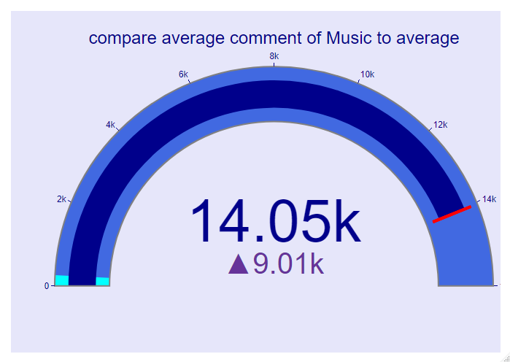

library(plotly)

library(sqldf)

a=sqldf("select sum(comment_count),count(video_id),category_id from a1 group by category_id")

a[,1]

a[,2]

b=52435252/3731

b

a1[,1]/a[,2]

b1=sum(a[,1])/sum(a[,2])

b1

b1=sum(a[,1])

c <- plot_ly(

type = "indicator",

mode = "gauge+number+delta",

value = b,

title = list(text = "compare average comment of Music to average", font = list(size = 24)),

delta = list(reference = b1, increasing = list(color = "RebeccaPurple")),

gauge = list(

axis = list(range = list(NULL, 16000), tickwidth = 1, tickcolor = "darkblue"),

bar = list(color = "darkblue"),

bgcolor = "white",

borderwidth = 2,

bordercolor = "gray",

steps = list(

list(range = c(0, 8000), color = "cyan"),

list(range = c(250, 16000), color = "royalblue")),

threshold = list(

line = list(color = "red", width = 4),

thickness = 0.75,

value = 14050)))

c <- c %>%

layout(

paper_bgcolor = "lavender",

font = list(color = "darkblue", family = "Arial"))

* **Bar Chart of video count based on category**

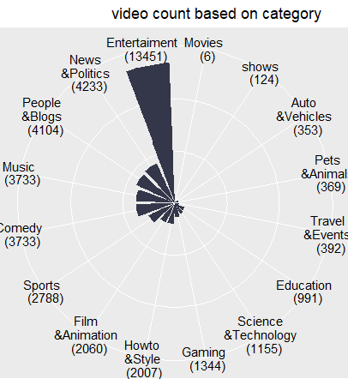

library(sqldf)

library(ggplot2)

a2<-sqldf("select category_id from a1")

a3=data.frame(table(a2))

a3

a3[,2][1]

a3[,2][2]

a3[,1][1]

a3[,2][14]

a3[,1]

g=v/sum(v)*100

p1=c(formatC(g,digits = 1,format = "f"))

p2=paste0(p1,"%")

p1

p2

v=sort(v)

v=c(a3[,2][1],a3[,2][2],a3[,2][3],a3[,2][4],a3[,2][5],a3[,2][6],a3[,2][7],a3[,2][8],a3[,2][9],a3[,2][10],a3[,2][11],a3[,2][12],a3[,2][13],a3[,2][14],a3[,2][15],a3[,2][16])

f=c("Movies \n (6)","shows \n (124)","Auto \n&Vehicles \n (353)","Pets \n&Animals \n (369)","Travel \n&Events \n (392)","Education \n (991)","Science \n&Technology \n (1155)","Gaming \n (1344)","Howto \n&Style \n(2007)","Film \n&Animation \n (2060)","Sports \n (2788)","Comedy \n (3733)","Music \n (3733)","People \n&Blogs \n (4104)","News \n&Politics \n (4233)","Entertaiment \n (13451)")

f

gh=data.frame(v,f)

ggplot(gh, aes(x=reorder(f,v), y=v)) +

geom_bar( stat="identity",fill="#34374a",width = 0.8) +

theme_grey()+ggtitle(" video count based on category")+

theme(axis.title.y = element_blank(), axis.title.x = element_blank(),axis.text = element_blank(), axis.ticks = element_blank())+theme(axis.text.x = element_text(angle=0))+coord_polar()

* **PieChart Of Comment Counts**

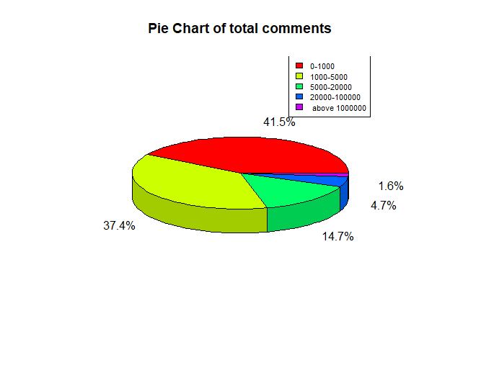

comment1k=nrow(table(subset(a1$comment_count,a1$comment_count<1000)))

comment5k=nrow(table(subset(a1$comment_count,a1$comment_count>1000 & a1$comment_count<5000)))

comment20k=nrow(table(subset(a1$comment_count,a1$comment_count>5000 & a1$comment_count<20000)))

comment50k=nrow(table(subset(a1$comment_count,a1$comment_count>20000 & a1$comment_count<100000)))

comment100k=nrow(table(subset(a1$comment_count,a1$comment_count>100000 & a1$comment_count<500000)))

comment500k=nrow(table(subset(a1$comment_count,a1$comment_count>500000 )))

comment1k1=nrow(table(subset(a1$comment_count,a1$comment_count<1000)))

comment1k1

print(comment1k)

print(comment5k)

print(comment20k)

print(comment50k)

print(comment100k)

print(comment500k)

p=c(comment1k,comment5k,comment20k,comment50k,comment100k,comment500k)

p1=(p/sum(p))*100

p1

p2=formatC(p1,digits = 1,format = "f")

t=pie(p,labels = paste0(p2,"%"),explode = 0,radius = .9,labelcex = 1, main = "Pie Chart of total comments")

t

g=c("0-1000","1000-5000","5000-20000","20000-100000"," above 1000000")

legend("topright",g,cex=0.8, fill=rainbow(length(t)))

* **Bar Graph of comparing 2017 and 2018 like, dislike and comments**

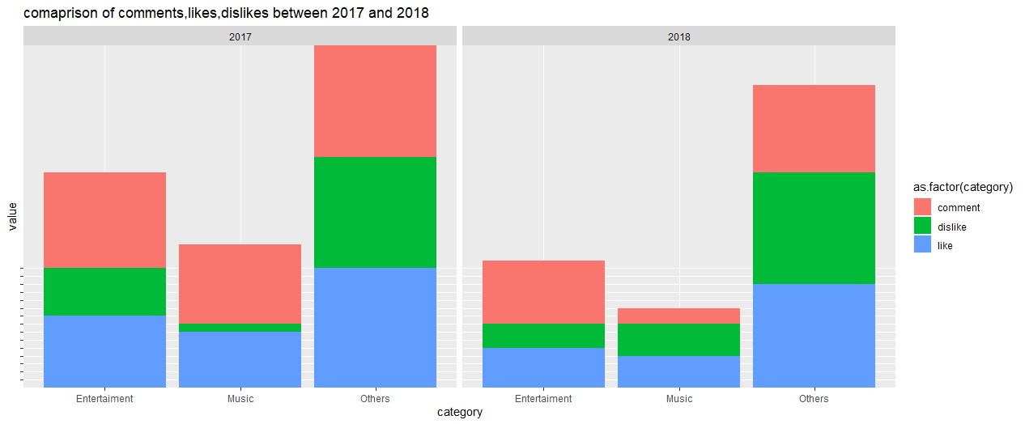

library(sqldf)

library(ggplot2)

s=sqldf("select sum(comment_count),category_id from a1 group by category_id")

s1=s[,1][4]

s11=s[,1][4]/sum(s[,1])

s11=s11*100

s11=formatC(s11,digits = 0,format = "f")

s11

s2=s[,1][9]/sum(s[,1])

s22=s2*100

s22=formatC(s22,digits = 0,format = "f")

s22

s3=sum(s[,1])-s1-s2

s33=s3/sum(s[,1])

s33=s33*100

s33=formatC(s33,digits = 0,format = "f")

s33

m=sqldf("select sum(likes),category_id from a1 group by category_id")

m1=m[,1][4]

m11=m[,1][4]/sum(m[,1])

m11=m11*100

m11=formatC(m11,digits = 0,format = "f")

m11

m2=m[,1][9]

m22=m2/sum(m[,1])

m2

m22=s2*100

m22=formatC(m22,digits = 0,format = "f")

m22

m33=100-24-25

m33=formatC(m33,digits = 0,format = "f")

m33

n=sqldf("select sum(dislikes),category_id from a1 group by category_id")

n1=n[,1][4]

n11=n[,1][4]/sum(n[,1])

n11=n11*100

n11=formatC(n11,digits = 0,format = "f")

n11

n2=n[,1][9]

n22=n2/sum(n[,1])

n2

n22=s2*100

n22=formatC(n22,digits = 0,format = "f")

n22

n3=sum(n[,1])-n1-n2

n33=n3/sum(n[,1])

n33=n33*100

n33=formatC(n33,digits = 0,format = "f")

n33

o=sqldf("select sum(comment_count),category_id from a1 where trending_date<='17.31.12' group by category_id")

o1=o[,1][4]

o11=o[,1][4]/sum(o[,1])

o11=o11*100

o11=formatC(o11,digits = 0,format = "f")

o11

o2=o[,1][9]/sum(o[,1])

o22=o2*100

o22=formatC(o22,digits = 0,format = "f")

o22

o33=100-34-3

o33=formatC(o33,digits = 0,format = "f")

o33

p=sqldf("select sum(likes),category_id from a1 where trending_date<='17.31.12' group by category_id")

p1=p[,1][4]

p11=p[,1][4]/sum(p[,1])

p11=p11*100

p11=formatC(p11,digits = 0,format = "f")

p11

p

p2=p[,1][9]

p22=p2/sum(p[,1])

p22

p22=p22*100

p22=formatC(p22,digits = 0,format = "f")

p22

p33=100-24-25

p33=formatC(p33,digits = 0,format = "f")

p33

q=sqldf("select sum(dislikes),category_id from a1 where trending_date<='17.31.12' group by category_id")

q1=q[,1][4]

q11=q[,1][4]/sum(q[,1])

q11=q11*100

q11=formatC(q11,digits = 0,format = "f")

q11

q2=q[,1][9]

q22=q2/sum(q[,1])

q22

q22=q22*100

q22=formatC(q22,digits = 0,format = "f")

q22

q33=100-45-4

q33=formatC(q33,digits = 0,format = "f")

q33

df <- data.frame("category" = c("like", "dislike","comment"),

"reason" = c("Entertaiment", "Entertaiment", "Entertaiment", "Music","Music","Music", "Others","Others", "Others","Entertaiment", "Entertaiment", "Entertaiment", "Music","Music","Music", "Others","Others", "Others"),

"time" = c("2017", "2017", "2017","2017","2017","2017","2017","2017","2017", "2018","2018","2018","2018","2018","2018", "2018", "2018","2018"),

"value" = c(o11,p11,q11,o22,p22,q22,o33,p33,q33,s11,m11,n11,s22,m22,n2,s33,m33,n33))

value

ggplot(data = df, aes(x = as.factor(reason), y = value)) +

geom_bar(aes(fill = as.factor(category)), stat = "identity") +

facet_grid(~time)+theme(axis.text.y = element_blank())+xlab("category")+ggtitle("comaprison of comments,likes,dislikes between 2017 and 2018")

* **Bar Graph of Comment & Rating disabled:**

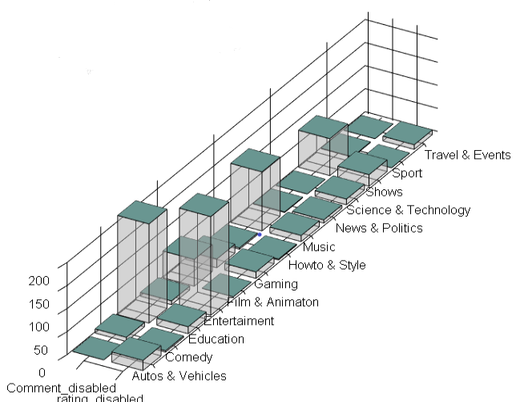

d1=sqldf("select count(comments_disabled),category_id from a1 where comments_disabled==TRUE group by category_id")

d1

d2=sqldf("select count(ratings_disabled),category_id from a1 where ratings_disabled==TRUE group by category_id")

d2

d3=sqldf("select count(video_error_or_removed),category_id from a1 where video_error_or_removed==TRUE group by category_id")

d3

x<-c(" Autos & Vehicles"," Comedy"," Education"," Entertaiment"," Film & Animaton"," Gaming"," Howto & Style"," Music"," News & Politics", " Science & Technology","Shows","Sport"," Travel & Events")

b<-c(0,22,9,3,215,15,8,214,58,0,19,14,3,2,128,13,1,7,0,12,80,25,1,0,0,10)

barplot3d(rows=13,cols=2,z=b,scalexy=80,alpha=0.3,theta=30,phi=30,

topcolors=c("#699691"),xlabels = c("Comment_disabled","rating_disabled"),ylabels=x,

)

* **Donut Graph of share of views of Entertainment & Music from all views**

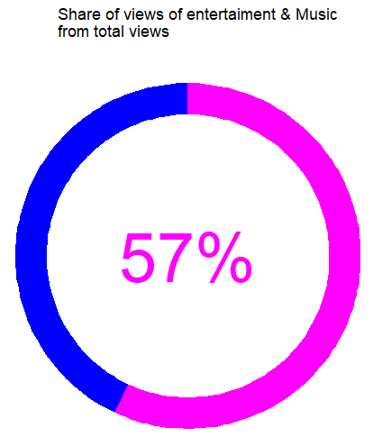

install.packages("ggiraph")

library(dplyr)

library(ggplot2)

library(ggiraph)

library(sqldf)

a=sqldf("select sum(views),category_id from a1 group by category_id")

c=sum(a[,1])

b=a[,1][4]+a[,1][9]

d=b/c

d

donut_data <- data.frame(type = c("Blue", "Pink"), value = c(43, 57)) %>%

mutate(

percentage = value / sum(value),

hover_text = paste0(type, ": ", value)

) %>%

mutate(percentage_label = paste0(round(100 * percentage, 1), "%"))

donut_plot <- ggplot(donut_data, aes(y = value, fill = type)) +

geom_bar_interactive(

aes(x = 1, tooltip = hover_text),

width = 0.2,

stat = "identity",

show.legend = FALSE

) +

annotate(

geom = "text",

x = 0,

y = 0,

label = donut_data[["percentage_label"]] [donut_data[["type"]] == "Pink"],

size = 20,

color = "magenta"

) +

scale_fill_manual(values = c(Blue = "blue", Pink = "magenta")) +

coord_polar(theta = "y") +

theme_void()

donut_plot+ggtitle(" Share of views of entertaiment & Music \n from total views")

ggtitle("hello")

ggiraph(ggobj=donut_plot)

* **Line Graph of tags count based on video category**

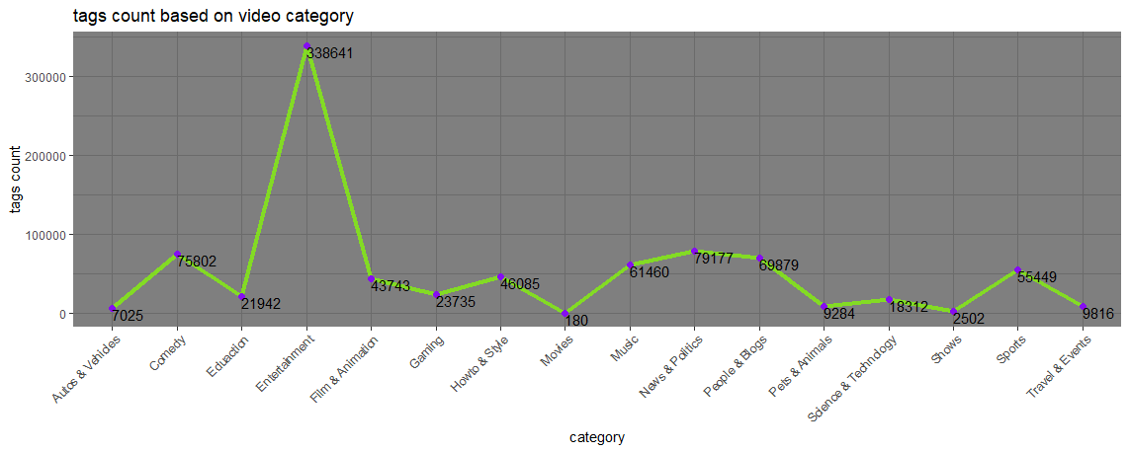

library(ggplot2)

library(sqldf)

library(stringr)

c=str_count(a1$tags,"[[:punct:]]")

d=c/2

aa1=formatC(d,digits = 0,format = "f")

da=data.frame(video_id=a1$video_id,category_id=a1$category_id,aa=aa1)

f=sqldf("select category_id,sum(aa) from da ASC group by category_id")

x=c("Autos & Vehicles","Comedy","Eduaction","Entertainment","Film & Animation","Gaming","Howto & Style","Movies","Music","News & Politics","People & Blogs","Pets & Animals","Science & Technology","Shows","Sports","Travel & Events")

y=c(7025,75802,21942,338641,43743,23735,46085,180,61460,79177,69879,9284,18312,2502,55449,9816)

dat=data.frame(x,y)

options(scipen=999)

ggplot(dat,aes(x=x,y=y,group=1))+ geom_line(color="#84f20d", size=1.5, alpha=.8, linetype=1)+theme_dark() +theme(axis.text.x = element_text(angle = 45,hjust = 1))+geom_point(color="#850ef1",size=2)+geom_text(label=y,vjust=1,hjust=0)+xlab("category")+ylab("tags count")+ggtitle("tags count based on video category")

* **Bar Graph of video views percentage based on category**

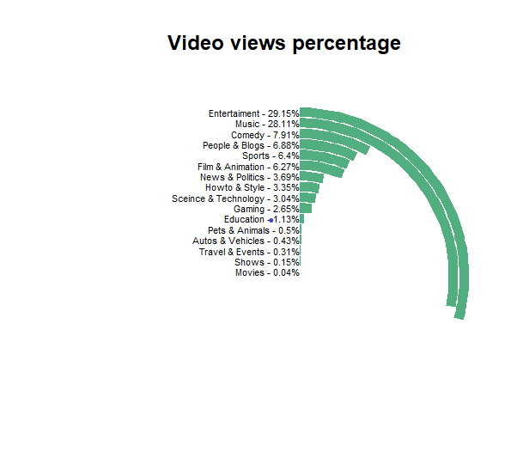

library(sqldf)

a3<-sqldf("select category_id ,sum(views) from a1 group by category_id")

Category <- c("Movies","Shows","Travel & Events","Autos & Vehicles","Pets & Animals","Education","Gaming","Sceince & Technology","Howto & Style","News & Politics", "Film & Animation","Sports","People & Blogs","Comedy","Music","Entertaiment")

#Percent <-c(a3[,2][1],a3[,2][2],a3[,2][3],a3[,2][4],a3[,2][5],a3[,2][6],a3[,2][7],a3[,2][8],a3[,2][9],a3[,2][10],a3[,2][11],a3[,2][12],a3[,2][13],a3[,2][14],a3[,2][15],a3[,2][16])

Percent<-c(0.04,0.15,0.31,0.43,0.50,1.13,2.65,3.04,3.35,3.69,6.27,6.40,6.88,7.91,28.11,29.15)

Percent1=Percent/sum(Percent)*100

p2=formatC(Percent1,digits = 2,format = "f")

#install.packages("hrbrthemes")

library(hrbrthemes)

i1<-data.frame(Category,Percent)

ggplot(i1, aes(x =reorder(Category,Percent), y = Percent,

fill = Category)) +

geom_bar(width = 0.9, stat="identity",fill="#51ae7e") +

coord_polar(theta = "y") +

xlab("") + ylab("") +

ylim(c(0,100)) +

ggtitle(" Video views percentage") +

geom_text(data =i1, hjust = 1, size = 3,

aes(x = Category, y = 0, label = paste0(Category," - ", Percent,"%")))+

theme_ipsum() +

theme(legend.position = "none",

panel.grid.major = element_blank(),

panel.grid.minor = element_blank(),

axis.line = element_blank(),

axis.text.y = element_blank(),

axis.text.x = element_blank(),

axis.ticks = element_blank())

* **Pie chart of Comment Enable/Disable**

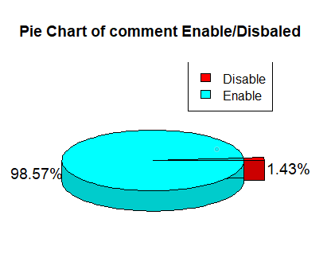

install.packages("plotrix")

library(plotrix)

p=c(tr,fa)

p1=(p/sum(p))*100

p1

p2=formatC(p1,digits = 2,format = "f")

t=pie3D(p,labels = paste0(p2,"%"),explode = 0.1,radius = .9,labelcex = 1.2, main = "Pie Chart of comment Enable/Disbaled ")

t

legend("topright",c("Disable","Enable"),cex=1, fill=rainbow(length(t)))

* **Bar Chart of Like & Dislike based on Category**

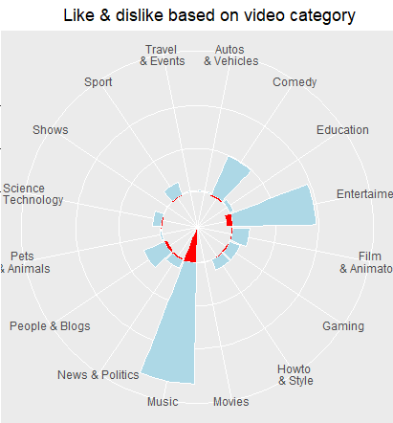

library(sqldf)

library(ggplot2)

a3<-sqldf("select category_id ,sum(likes),sum(dislikes) from a1 group by category_id")

x<-c("Autos \n& Vehicles","Comedy","Education","Entertaiment","Film\n& Animaton","Gaming","Howto\n & Style","Movies","Music","News & Politics", "People & Blogs","Pets \n& Animals","Science\n & Technology","Shows","Sport","Travel \n& Events")

a<-c(a3[,2][1],a3[,2][2],a3[,2][3],a3[,2][4],a3[,2][5],a3[,2][6],a3[,2][7],a3[,2][8],a3[,2][9],a3[,2][10],a3[,2][11],a3[,2][12],a3[,2][13],a3[,2][14],a3[,2][15],a3[,2][16])

b<-c(a3[,3][1],a3[,3][2],a3[,3][3],a3[,3][4],a3[,3][5],a3[,3][6],a3[,3][7],a3[,3][8],166666666,a3[,3][10],a3[,3][11],a3[,3][12],a3[,3][13],a3[,3][14],a3[,3][15],a3[,3][16])

y=append(a,b*-1)

data<-data.frame(s,y)

data

options(scipen=999)

ggplot(data, aes(x = x, y = y)) +

geom_bar(

aes(x,y),

stat = "identity", position = position_stack(),

color = "white", fill = "lightblue",

subset(data,subset = y>0)

) +

geom_bar(

aes(x,y),

stat = "identity",

fill="red",

subset(data,subset = y<0)

)+coord_polar()+theme(axis.title.x = element_blank(),axis.text.y =element_blank(),axis.title.y = element_blank() )+

ggtitle(" Like & dislike based on video category")

* **Pie Chat of total Views**

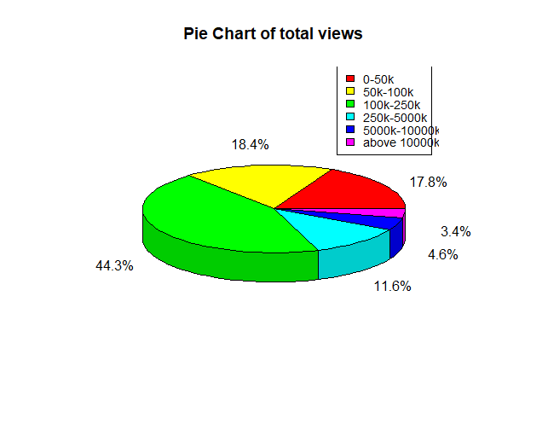

library("plotrix")

views50k=nrow(table(subset(a1$views, subset = a1$views<50000)))

views100k=nrow(table(subset(a1$views, subset= a1$views>50000 & a1$views<100000)))

views250k=nrow(table(subset(a1$views,subset = a1$views >100000 & a1$views<250000)))

views500k=nrow(table(subset(a1$views,subset = a1$views >2500000 & a1$views<5000000 )))

views1000k=nrow(table(subset(a1$views,subset= a1$views>5000000 & a1$views<10000000)))

views2000k=nrow(table(subset(a1$views,subset =a1$views>10000000)))

p=c(views50k,views100k,views250k,views500k,views1000k,views2000k)

p1=(p/sum(p))*100

p1

p2=formatC(p1,digits = 1,format = "f")

g=c("0-50k","50k-100k","100k-250k","250k-5000k","5000k-10000k","above 10000k")

t=pie3D(p,labels = paste0(p2,"%"),explode =0 ,radius = .9,labelcex = 1, main = "Pie Chart of total views")

t

legend("topright",g,cex=0.9, fill=rainbow(length(t)))

* **Area Graph like, dislike comparison**

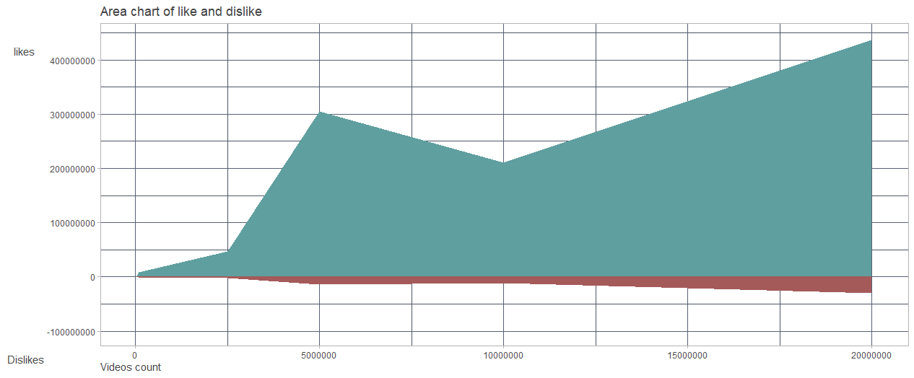

library(ggplot2)

likes50k=sum(subset(a1$likes, subset=(a1$views<50000)))

likes100k=sum(subset(a1$likes, subset=(a1$views>50000 & a1$views<100000)))

likes250k=sum(subset(a1$likes, subset=(a1$views>100000 & a1$views<250000)))

likes500k=sum(subset(a1$likes, subset=(a1$views>2500000 & a1$views<5000000 )))

likes1000k=sum(subset(a1$likes, subset=(a1$views>5000000 & a1$views<10000000)))

likes2000k=sum(subset(a1$likes, subset=(a1$views>10000000)))

dislikes50k=sum(subset(a1$dislikes, subset=(a1$views<50000)))

dislikes100k=sum(subset(a1$dislikes, subset=(a1$views>50000 & a1$views<100000)))

dislikes250k=sum(subset(a1$dislikes, subset=(a1$views>100000 & a1$views<250000)))

dislikes500k=sum(subset(a1$dislikes, subset=(a1$views>2500000 & a1$views<5000000 )))

dislikes1000k=sum(subset(a1$dislikes, subset=(a1$views>5000000 & a1$views<10000000)))

dislikes2000k=sum(subset(a1$dislikes, subset=(a1$views>10000000)))

sum(dislikes50k)

like=c()

like=c(likes50k,likes100k,likes250k,likes500k,likes1000k,likes2000k)

dislike=c(dislikes50k,dislikes100k,dislikes250k,dislikes500k,dislikes1000k,dislikes2000k)

y=append(like,dislike*-1)

y

options(scipen=999)

x=c(50000,100000,2500000,5000000,10000000,20000000)

length(y)

length(x)

li=data.frame(x,y)

ggplot(li,aes(x=x,y=y))+ylim(-100000000,440000000)+ geom_area(fill="#a55a5a", aes(x=x,y=y),subset(li,subset=y<0))+geom_area(fill="#609f9f",aes(x,y),subset(li,subset=y>0))+theme_light()+theme(legend.position = c(0.95,0.95),legend.justification = c("vbfh","fdn"))+labs(x="Videos count",y="\n\nlikes\n\n\n\n\n\n\n\n\n\n\n\n\n\n\n\n\n\n\n\n\n\n\n\n\n\n\n Dislikes",title = "Area chart of like and dislike")+theme(text = element_text(family = 'Gill Sans',colour = "#444444"),panel.grid.minor = element_line(color='#4d5566'),panel.grid.major = element_line(color = '#586174'),axis.title.y = element_text(vjust = 1,angle = 0),axis.title.x = element_text(hjust = 0))

* **Lolipop Graph of average like and dislike based on catgory**

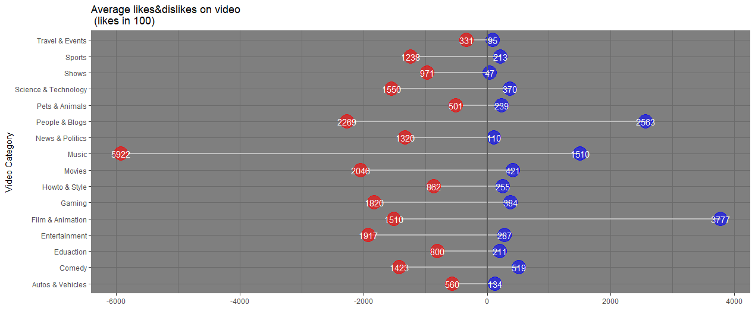

library(ggplot2)

library(sqldf)

f=sqldf("select category_id,sum(likes),sum(dislikes) from a1 group by category_id")

d=sqldf("select count(video_id),category_id from a1 group by category_id")

d

f

x=c("Autos & Vehicles","Comedy","Eduaction","Entertainment","Film & Animation","Gaming","Howto & Style","Movies","Music","News & Politics","People & Blogs","Pets & Animals","Science & Technology","Shows","Sports","Travel & Events")

#a=c(13405,51960,21162,28789,377767,38487,25502,42106,151042,10145,256333,23931,37068,4752,21390,9568)

b=c(-560,-1423,-800,-1917,-1510,-1820,-862,-2046,-5922,-1320,-2269,-501,-1550,-971,-1238,-331)

z=c(13,51,21,28,377,38,25,42,151,10,256,23,37,4,21,9,-560,-1423,-800,-1917,-1510,-1820,-862,-2046,-5922,-1320,-2269,-501,-1550,-971,-1238,-331)

a=c(134,519,211,287,3777,384,255,421,1510,110,2563,239,370,47,213,95)

a=a/100

length(z1)

length(z2)

a=formatC(a,digits = 0,format = "f")

z1

z=append(a,b)

z

a=a

da=data.frame(x,z,a,b)

length(z)

z

a

b

z

ggplot(da,aes(x,z))+

geom_segment(aes(x = x, y = 0, xend = x, yend =z ), color = "grey50")+

geom_point(color="blue",size=8,alpha=0.6,aes(x,a), subset(da,subset = z>0))+

geom_segment(aes(x=x,xend=x,y=1,yend=b),color="grey",size=1)+

geom_segment(aes(x=x,xend=x,y=0,yend=a),color="grey",size=1)+

geom_point(color="red",size=8,alpha=0.6, aes(x,z), subset(da,subset = z<0))+

geom_hline(aes(yintercept = 0), color = "grey35", size = 1) +

geom_text(label=a,aes(x,a),color="white", subset(da,subset = z<0))+

geom_text(label=b*-1,aes(x,b),color="white", subset(da,subset = z>0))+

theme(panel.grid.major = element_blank(),

panel.border = element_blank(),

axis.ticks.y = element_blank(),

axis.text.x = element_text(angle = 45,hjust=1))+ylab("")+

coord_flip()+

theme_dark()+

xlab("Video Category")+

ggtitle("Average likes&dislikes on video \n (likes in 100) ")

* **Donut Graph of Rating Enabled/Disables**

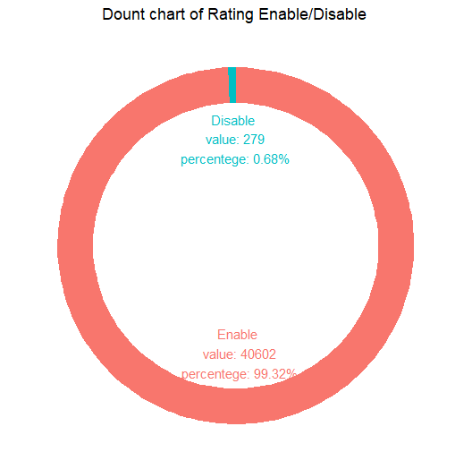

data<-file("C:/krunal/CAvideos.csv")

da=data.frame(data)

a2<-sqldf("select ratings_disabled from a1")

a3=data.frame(table(a2))

a3[,2][1]

a3[,2][2]

library(ggplot2)

library(plotrix)

p=c(a3[,2][1],a3[,2][2])

p1=(p/sum(p))*100

p1

p2=formatC(p1,digits = 2,format = "f")

data <- data.frame(

category=c("Enable","Disable"),

count=p

)

data$fraction <- data$count / sum(data$count)

data$ymax <- cumsum(data$fraction)

data$ymin <- c(0, head(data$ymax, n=-1))

data$labelPosition <- (data$ymax + data$ymin) / 2

data$label <- paste0(data$category, "\n value: ", data$count, "\n percentege: ",p2,"%")

ggplot(data, aes(ymax=ymax, ymin=ymin, xmax=4, xmin=3, fill=c("blue","red"))) +

geom_rect() +

geom_text( x=2, aes(y=labelPosition, label=label, color=c("blue","red")), size=4) +

coord_polar(theta="y") +

xlim(c(-1, 4)) +

theme_void() +

theme(legend.position = "none")+labs(x="",y="",title = " Dount chart of Rating Enable/Disable")

* **Radar Graph of video percentage based on category**

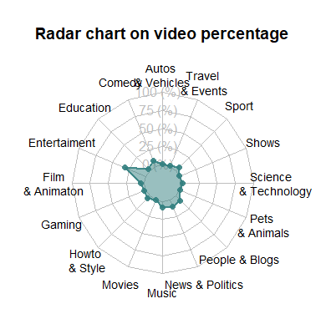

library(fmsb)

data as.data.frame(matrix(c(a3[,2][1],a3[,2][2],a3[,2][3],a3[,2][4],a3[,2][5],a3[,2][6],a3[,2][7],a3[,2][8],a3[,2][9],a3[,2][10],a3[,2][11],a3[,2][12],a3[,2][13],a3[,2][14],a3[,2][15],a3[,2][16]) , ncol=16))

colnames(data) <- c("Autos \n& Vehicles","Comedy","Education","Entertaiment","Film\n& Animaton","Gaming","Howto\n & Style","Movies","Music","News & Politics", "People & Blogs","Pets \n& Animals","Science\n & Technology","Shows","Sport","Travel \n& Events")

data <- rbind(rep(43000,43000) , rep(0,43000) , data)

data

radarchart( data , axistype=1 ,

pcol=rgb(0.2,0.5,0.5,0.9) , pfcol=rgb(0.2,0.5,0.5,0.5) , plwd=2 ,

cglcol="grey", cglty=1, axislabcol="grey", cglwd=0.8,

vlcex=0.9

)

title("Radar chart on video percentage")

* **Dot Graph of video error or removed based on category**

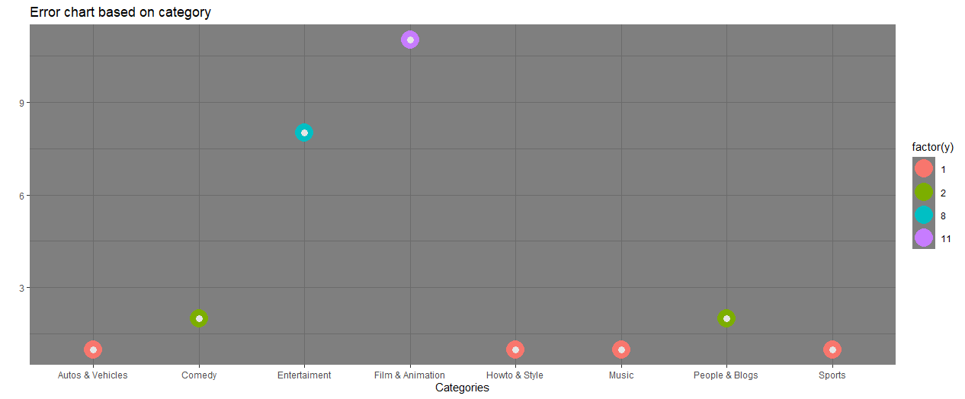

library(ggplot2)

library(sqldf)

s1=sqldf("select count(video_error_or_removed),category_id from a1 where video_error_or_removed=TRUE group by category_id")

s1

x=c("Autos & Vehicles","Comedy","Entertaiment","Film & Animation","Howto & Style","Music","People & Blogs","Sports")

y=c(1,2,8,11,1,1,2,1)

y

h=data.frame(x,y)

ggplot(h,aes(x=x,y=y))+

geom_point(aes(colour=factor(y)),size=8)+

geom_point(colour="grey90",size=3)+

theme_dark()+xlab("Categories")+ggtitle("Error chart based on category")+ylab("")

* **Bar Graph of like and dislike based on category**

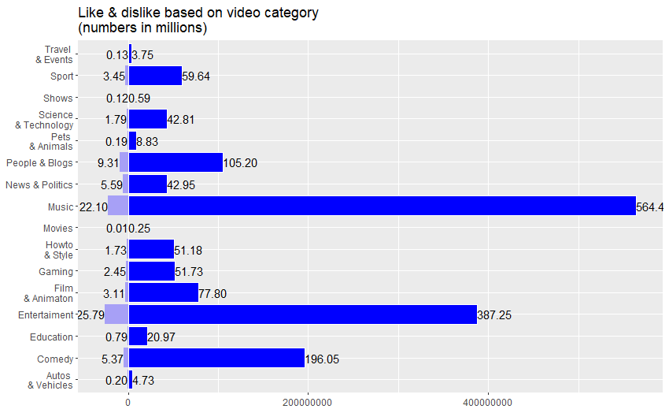

library(sqldf)

library(ggplot2)

a3<-sqldf("select category_id ,sum(likes),sum(dislikes) from a1 group by category_id")

x<-c("Autos \n& Vehicles","Comedy","Education","Entertaiment","Film\n& Animaton","Gaming","Howto\n & Style","Movies","Music","News & Politics", "People & Blogs","Pets \n& Animals","Science\n & Technology","Shows","Sport","Travel \n& Events")

a<-c(a3[,2][1],a3[,2][2],a3[,2][3],a3[,2][4],a3[,2][5],a3[,2][6],a3[,2][7],a3[,2][8],a3[,2][9],a3[,2][10],a3[,2][11],a3[,2][12],a3[,2][13],a3[,2][14],a3[,2][15],a3[,2][16])

b<-c(a3[,3][1],a3[,3][2],a3[,3][3],a3[,3][4],a3[,3][5],a3[,3][6],a3[,3][7],a3[,3][8],a3[,3][9],a3[,3][10],a3[,3][11],a3[,3][12],a3[,3][13],a3[,3][14],a3[,3][15],a3[,3][16])

aa=a/1000000

bb=b/1000000

aa1=formatC(aa,digits = 2,format = "f")

bb1=formatC(bb,digits = 2,format = "f")

y=append(a,b*-1)

data<-data.frame(s,y)

data

options(scipen=999)

ggplot(data, aes(x = x, y = y,fill=y)) +

geom_bar(

aes(x,y),

stat = "identity", position = position_stack(),

color = "white", fill = "blue",

subset(data,subset = y>0)

) +

geom_bar(

aes(x,y,fill=y),

stat = "identity",

fill="#a7a0f6",

subset(data,subset = y<0)

)+geom_text(aes(x,y),label=aa1, subset(data,subset = y>0),hjust=0)+

geom_text(aes(x,y),label=bb1,subset(data,subset = y<0),hjust=1)+

coord_flip()+

ggtitle("Like & dislike based on video category \n(numbers in millions)")+theme(axis.title.x = element_blank(),axis.title.y = element_blank())

* **Lollipop Graph of Average tags used by videos based on category**

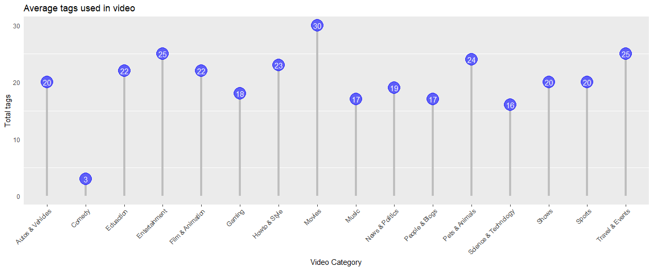

library(ggplot2)

library(sqldf)

library(stringr)

c=str_count(a1$tags,"[[:punct:]]")

d=c/2

aa1=formatC(d,digits = 0,format = "f")

aa1

da=data.frame(video_id=a1$video_id,category_id=a1$category_id,aa=aa1)

da

f=sqldf("select category_id,sum(aa) from da ASC group by category_id")

d=sqldf("select count(video_id),category_id from a1 group by category_id")

d

f

x=c("Autos & Vehicles","Comedy","Eduaction","Entertainment","Film & Animation","Gaming","Howto & Style","Movies","Music","News & Politics","People & Blogs","Pets & Animals","Science & Technology","Shows","Sports","Travel & Events")

y=c(7025,75802,21942,338641,43743,23735,46085,180,61460,79177,69879,9284,18312,2502,55449,9816)

z=c(20,3,22,25,22,18,23,30,17,19,17,24,16,20,20,25)

da=data.frame(x,z)

da

ggplot(da,aes(x,z))+

geom_segment(aes(x=x,xend=x,y=0,yend=z-1.5),color="grey",size=1)+

geom_point(color="blue",size=8,alpha=0.6)+

geom_text(label=z,color="white")+

theme(panel.grid.major = element_blank(),

panel.border = element_blank(),

axis.ticks.y = element_blank(),

axis.text.x = element_text(angle = 45,hjust=1))+ylab("Total tags")+xlab("Video Category")+ggtitle("Average tags used in video")

1. **CONCLUSION**

This analysis is created for better understanding. It working fine in all situation and ready to get implemented in real world problems.

As perfection has no limit in the same way there are many future scopes where we try toimplement more functionality to this analysis such as dynamic data like online dataand do analysis etc.

1. **BIBLIOGRAPHY**

* **References**
* [www.tutorialspoint.com](http://www.tutorialspoint.com)
* [www.r-tutor.com](http://www.r-tutor.com)
* [www.W3schools.in](http://www.W3schools.in)
* www.r-graph-gallery.com
* <https://rpubs.com/CosHoef/159665>